**Create your first function in the Azure portal**

Azure Functions lets you run your code in a serverless environment without having to first create a virtual machine (VM) or publish a web application. In this article, you learn how to use Azure Functions to create a "hello world" HTTP trigger function in the Azure portal.

We recommend that you [develop your functions locally](https://docs.microsoft.com/en-us/azure/azure-functions/functions-develop-local) and publish to a function app in Azure.  
Use one of the following links to get started with your chosen local development environment and language:

| **CREATE YOUR FIRST FUNCTION IN THE AZURE PORTAL** | | |
| --- | --- | --- |
| **Visual Studio Code** | **Terminal/command prompt** | **Visual Studio** |
| • [Get started with C#](https://docs.microsoft.com/en-us/azure/azure-functions/functions-create-first-function-vs-code?pivots=programming-language-csharp) • [Get started with Java](https://docs.microsoft.com/en-us/azure/azure-functions/functions-create-first-function-vs-code?pivots=programming-language-java) • [Get started with JavaScript](https://docs.microsoft.com/en-us/azure/azure-functions/functions-create-first-function-vs-code?pivots=programming-language-javascript) • [Get started with PowerShell](https://docs.microsoft.com/en-us/azure/azure-functions/functions-create-first-function-vs-code?pivots=programming-language-powershell) • [Get started with Python](https://docs.microsoft.com/en-us/azure/azure-functions/functions-create-first-function-vs-code?pivots=programming-language-python) | • [Get started with C#](https://docs.microsoft.com/en-us/azure/azure-functions/functions-create-first-azure-function-azure-cli?pivots=programming-language-csharp) • [Get started with Java](https://docs.microsoft.com/en-us/azure/azure-functions/functions-create-first-azure-function-azure-cli?pivots=programming-language-java) • [Get started with JavaScript](https://docs.microsoft.com/en-us/azure/azure-functions/functions-create-first-azure-function-azure-cli?pivots=programming-language-javascript) • [Get started with PowerShell](https://docs.microsoft.com/en-us/azure/azure-functions/functions-create-first-azure-function-azure-cli?pivots=programming-language-powershell) • [Get started with Python](https://docs.microsoft.com/en-us/azure/azure-functions/functions-create-first-azure-function-azure-cli?pivots=programming-language-python) | [Get started with C#](https://docs.microsoft.com/en-us/azure/azure-functions/functions-create-your-first-function-visual-studio) |

If you don't have an [Azure subscription](https://docs.microsoft.com/en-us/azure/guides/developer/azure-developer-guide#understanding-accounts-subscriptions-and-billing), create a [free account](https://azure.microsoft.com/free/?ref=microsoft.com&utm_source=microsoft.com&utm_medium=docs&utm_campaign=visualstudio) before you begin.

**Sign in to Azure**

Sign in to the [Azure portal](https://portal.azure.com/) with your Azure account.

**Create a function app**

You must have a function app to host the execution of your functions. A function app lets you group functions as a logical unit for easier management, deployment, scaling, and sharing of resources.

1. From the Azure portal menu or the **Home** page, select **Create a resource**.
2. In the **New** page, select **Compute** > **Function App**.
3. On the **Basics** page, use the function app settings as specified in the following table.

| **TABLE 2** | | |
| --- | --- | --- |
| **Setting** | **Suggested value** | **Description** |
| **Subscription** | Your subscription | The subscription under which this new function app is created. |
| [**Resource Group**](https://docs.microsoft.com/en-us/azure/azure-resource-manager/management/overview) | *myResourceGroup* | Name for the new resource group in which to create your function app. |
| **Function App name** | Globally unique name | Name that identifies your new function app. Valid characters are a-z (case insensitive), 0-9, and -. |
| **Publish** | Code | Option to publish code files or a Docker container. |
| **Runtime stack** | Preferred language | Choose a runtime that supports your favorite function programming language. Choose **.NET Core** for C# and F# functions. |
| **Version** | Version number | Choose the version of your installed runtime. |
| **Region** | Preferred region | Choose a [region](https://azure.microsoft.com/regions/) near you or near other services your functions access. |

1. 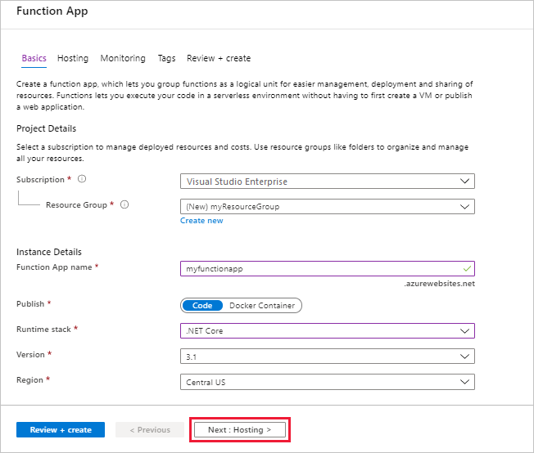
2. Select **Next : Hosting**. On the **Hosting** page, enter the following settings.

| **TABLE 3** | | |
| --- | --- | --- |
| **Setting** | **Suggested value** | **Description** |
| [**Storage account**](https://docs.microsoft.com/en-us/azure/storage/common/storage-account-create) | Globally unique name | Create a storage account used by your function app. Storage account names must be between 3 and 24 characters in length and can contain numbers and lowercase letters only. You can also use an existing account, which must meet the [storage account requirements](https://docs.microsoft.com/en-us/azure/azure-functions/functions-scale#storage-account-requirements). |
| **Operating system** | Preferred operating system | An operating system is pre-selected for you based on your runtime stack selection, but you can change the setting if necessary. |
| [**Plan**](https://docs.microsoft.com/en-us/azure/azure-functions/functions-scale) | **Consumption (Serverless)** | Hosting plan that defines how resources are allocated to your function app. In the default **Consumption** plan, resources are added dynamically as required by your functions. In this [serverless](https://azure.microsoft.com/overview/serverless-computing/) hosting, you pay only for the time your functions run. When you run in an App Service plan, you must manage the [scaling of your function app](https://docs.microsoft.com/en-us/azure/azure-functions/functions-scale). |

1. 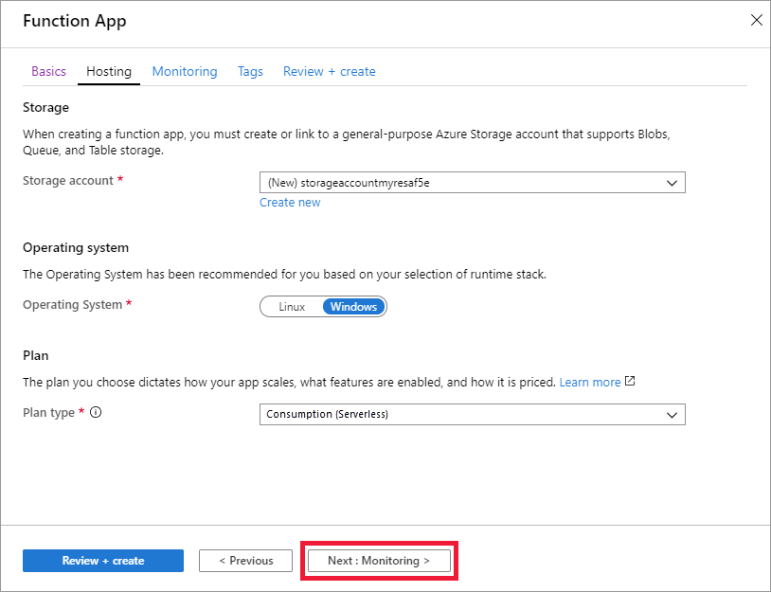
2. Select **Next : Monitoring**. On the **Monitoring** page, enter the following settings.

| **TABLE 4** | | |
| --- | --- | --- |
| **Setting** | **Suggested value** | **Description** |
| [**Application Insights**](https://docs.microsoft.com/en-us/azure/azure-functions/functions-monitoring) | Default | Creates an Application Insights resource of the same *App name* in the nearest supported region. By expanding this setting or selecting **Create new**, you can change the Application Insights name or choose a different region in an [Azure geography](https://azure.microsoft.com/global-infrastructure/geographies/) where you want to store your data. |

1. 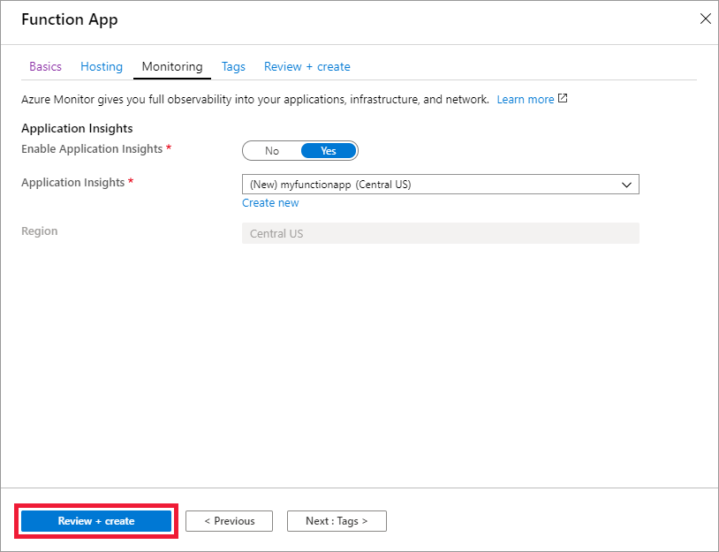
2. Select **Review + create** to review the app configuration selections.
3. On the **Review + create** page, review your settings, and then select **Create** to provision and deploy the function app.
4. Select the **Notifications** icon in the upper-right corner of the portal and watch for the **Deployment succeeded** message.
5. Select **Go to resource** to view your new function app. You can also select **Pin to dashboard**. Pinning makes it easier to return to this function app resource from your dashboard.

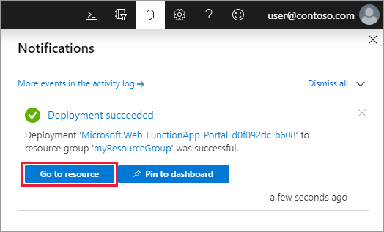

Next, create a function in the new function app.

**Create an HTTP trigger function**

1. From the left menu of the **Functions** window, select **Functions**, then select **Add** from the top menu.
2. From the **New Function** window, select **Http trigger**.

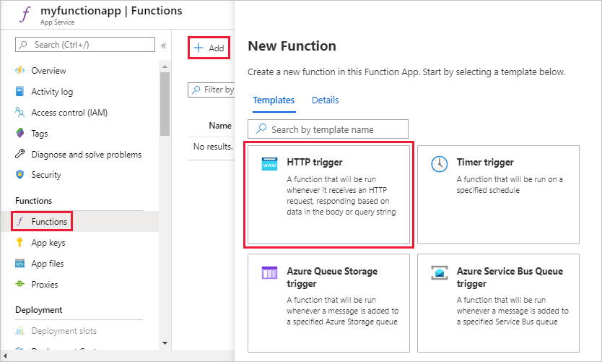

1. In the **New Function** window, accept the default name for **New Function**, or enter a new name.
2. Choose **Anonymous** from the **Authorization level** drop-down list, and then select **Create Function**.

Azure creates the HTTP trigger function. Now, you can run the new function by sending an HTTP request.

**Test the function**

1. In your new HTTP trigger function, select **Code + Test** from the left menu, then select **Get function URL** from the top menu.

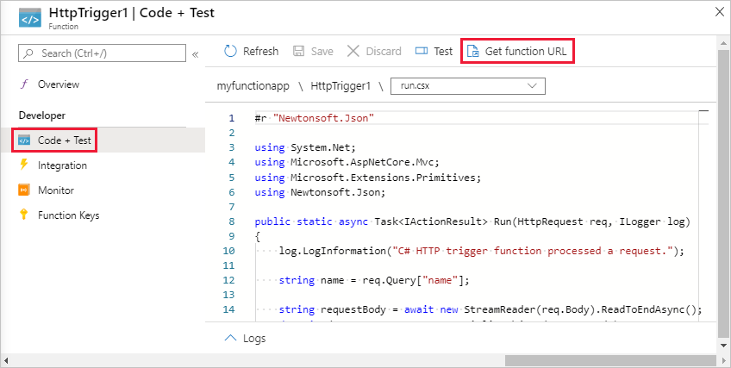

1. In the **Get function URL** dialog box, select **default** from the drop-down list, and then select the **Copy to clipboard** icon.

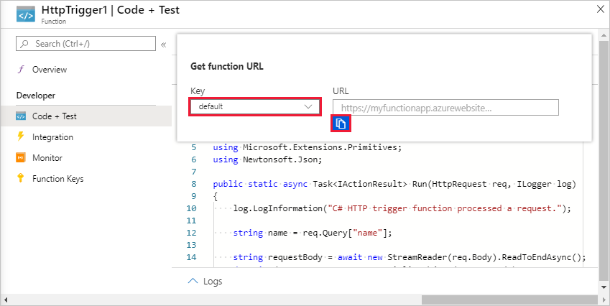

1. Paste the function URL into your browser's address bar. Add the query string value ?name=<your_name> to the end of this URL and press Enter to run the request.

The following example shows the response in the browser:

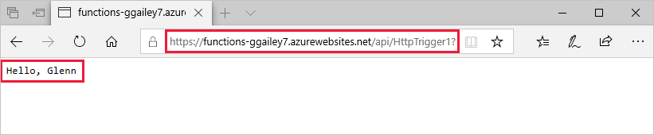

The request URL includes a key that is required, by default, to access your function over HTTP.

1. When your function runs, trace information is written to the logs. To see the trace output, return to the **Code + Test** page in the portal and expand the **Logs** arrow at the bottom of the page.

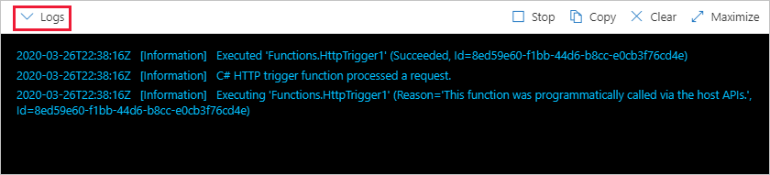

**Clean up resources**

Other quickstarts in this collection build upon this quickstart. If you plan to work with subsequent quickstarts, tutorials, or with any of the services you have created in this quickstart, do not clean up the resources.

*Resources* in Azure refer to function apps, functions, storage accounts, and so forth. They're grouped into *resource groups*, and you can delete everything in a group by deleting the group.

You created resources to complete these quickstarts. You may be billed for these resources, depending on your [account status](https://azure.microsoft.com/account/) and [service pricing](https://azure.microsoft.com/pricing/). If you don't need the resources anymore, here's how to delete them:

1. In the Azure portal, go to the **Resource group** page.

To get to that page from the function app page, select the **Overview** tab and then select the link under **Resource group**.

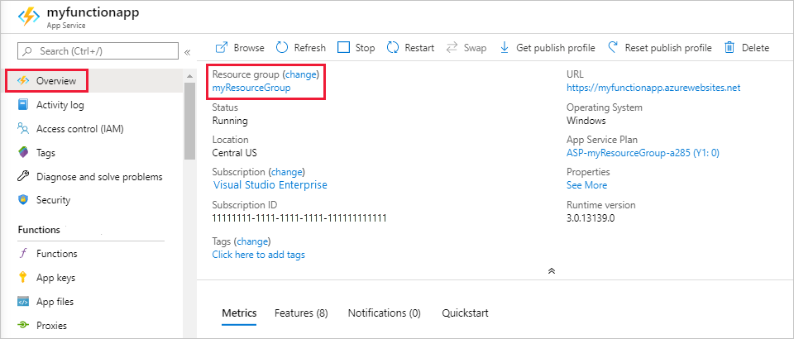

To get to that page from the dashboard, select **Resource groups**, and then select the resource group that you used for this quickstart.

1. In the **Resource group** page, review the list of included resources, and verify that they're the ones you want to delete.
2. Select **Delete resource group**, and follow the instructions.

Deletion may take a couple of minutes. When it's done, a notification appears for a few seconds. You can also select the bell icon at the top of the page to view the notification.